Quinn Knudsen

Homework 2

Topic: **Basic Probability**

1. Heads = 1 Tails = 0

Example 1

> round(table( rbinom(n=9, size=1, prob=0.5) )/9,2)

0 1

0.11 0.89

Example 2

> table( rbinom(n=1,size=9,prob=0.5) )

7

1

Example 1

> round(table( rbinom(n=100000, size=1, prob=0.5) )/100000,4)

0 1

0.5021 0.4979

Example 2

> table( rbinom(n=100000,size=9,prob=0.5) )

0 1 2 3 4 5 6 7 8 9

180 1730 7110 16458 24526 24539 16427 7014 1788 228

These results exemplify the power of sample size. In the first slipping scenario, only 8 heads and 1 tail were ‘thrown’ indicating heads occurs 89% of the time. This might mislead you to conclude the coin you are flipping is unfair. However, after replicating this 100,000 times, it is clear to see there is parity in the outcome.

In the second example, it demonstrates that one trial leads one to believe heads occurs 7 times (70%) whereas over 100,000 iterations of this test we see that the most common is between 4 and 5 heads as one would expect by random chance. A great view of the normal distribution achieved can be found on page 3.

2)

data1 <- round(table( rbinom(n=9, size=1, prob=0.5) )/9,2)

barplot(data1, main="9 Coin Flips"

,xlab="Probability of Heads or Tails"

,names.arg=c("Heads", "Tails")

, col=c("darkblue","red")

)

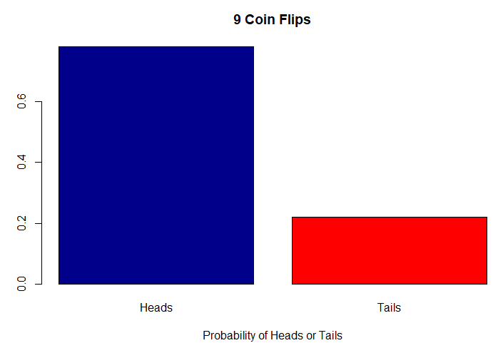

data2 <- round(table( rbinom(n=100000, size=1, prob=0.5) )/100000,4)

barplot(data2, main="100,000 Coin Flips"

,xlab="Probability of Heads or Tails"

,names.arg=c("Heads", "Tails")

, col=c("darkblue","red")

)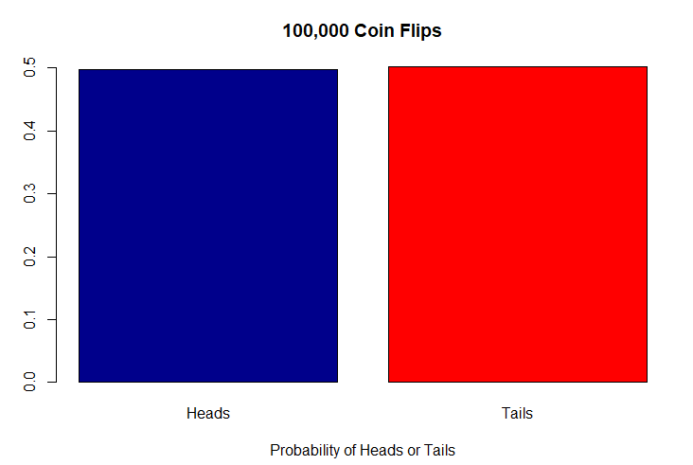

barplot(table( rbinom(n=1,size=9,prob=0.5) ),main="1 trial of 9 Coin Flips")

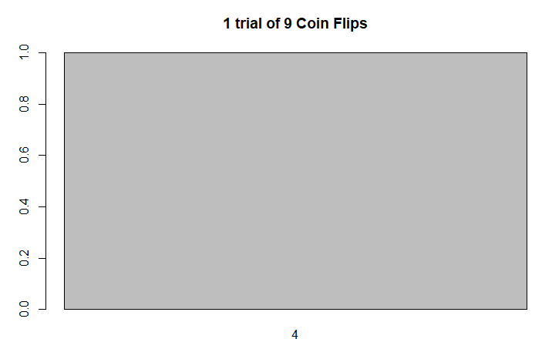

This bar plot signifies the number of heads found in one experiment of 9 flips.

barplot(table( rbinom(n=100000,size=9,prob=0.5) ), main="100,000 trails of 9 Coin Flips")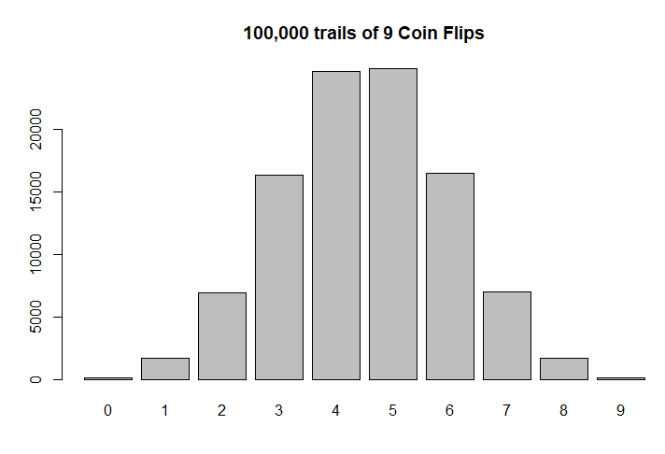

This bar plot shows the number of heads achieved in 100,000 experiments of 9 flips. The previous plot represents one trial in the 100,000 shown here and is fairly representative for what is seen when enough experiments are run to find a normal distribution. It is clear to see the mean median are around 4.5 and the mode is 5 (just slightly more frequent than 4). This makes sense because a 50/50 representation of 9 flips would be 4 or 5 heads (44% or 55%). Because there is an odd number of flips, it would fall between those two aforementioned values.

6)

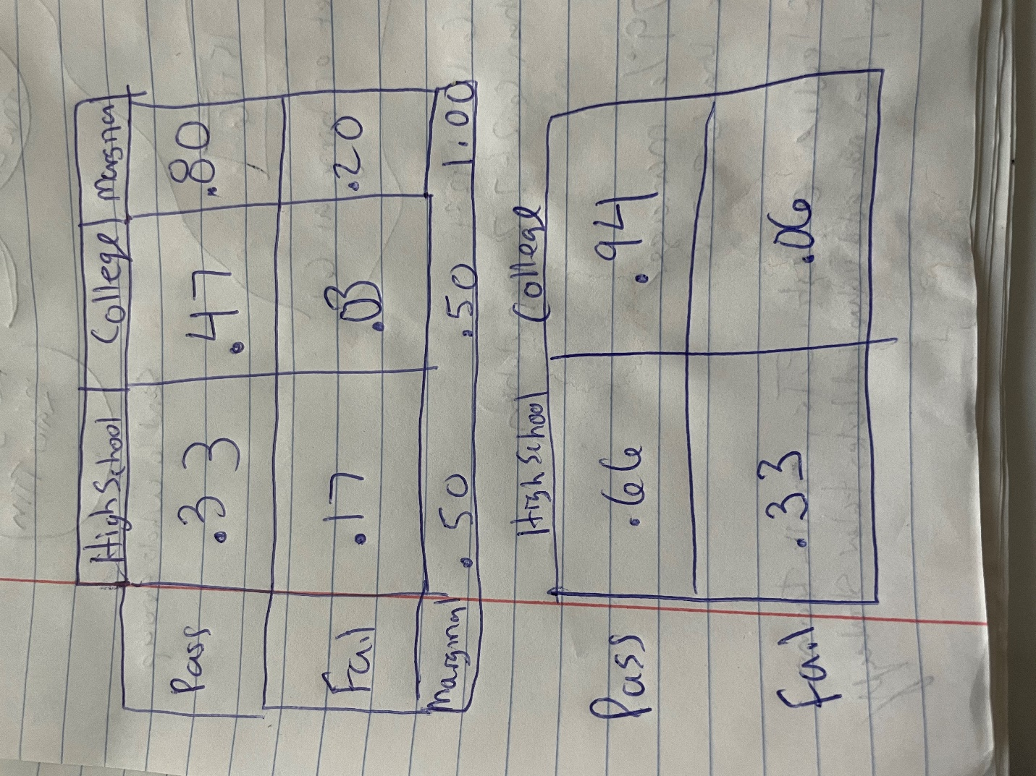

> toast <- matrix(c(33,47,17,3),ncol=2,byrow=TRUE)

> colnames(toast)<- c("Pass","Fail")

> rownames(toast)<- c("Default","No Default")

> toast <- as.table(toast)

> toast

Pass Fail

Default 33 47

No Default 17 3

> toast/margin.table(toast)

Pass Fail

Default 0.33 0.47

No Default 0.17 0.03

The additional piece of information clearly identifies the other missing values because given the known parameters of 20 fail and 50 college students, you can subtract the 3 from 50 to get 47 students and 3 from 20 to get 17 failure. The remainder is 50-17 fail for high school students and 47-80 pass, both of which check out to equal 33. High school students pass 66% of the time.



7) Below are the tables used to solve this problem. 94% of customers who pass the test do not have their homes repossessed (94% of all customer outcomes).

> toast <- matrix(c(2,69,93933,5996),ncol=2,byrow=TRUE)

> colnames(toast)<- c("Pass","Fail")

> rownames(toast)<- c("Default","No Default")

> toast <- as.table(toast)

> toast

Pass Fail

Default 2 69

No Default 93933 5996

> toast/margin.table(toast)

Pass Fail

Default 0.00002 0.00069

No Default 0.93933 0.05996

8) If the customer fails the test, they will have a 1% chance of not paying their mortgage. We would not be able to extrapolate the information from the statistics test in problem 6 as there is insufficient information about the relationship between the test and the mortgage to create this table. They are likely samples that are not associated with one another.

